Section 1

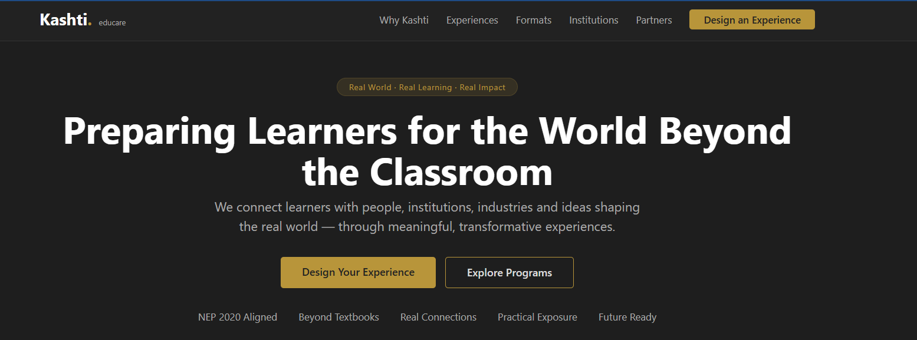

Section 2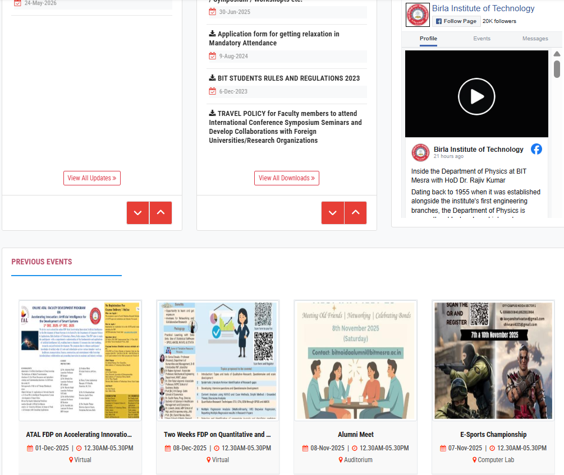
Section 2
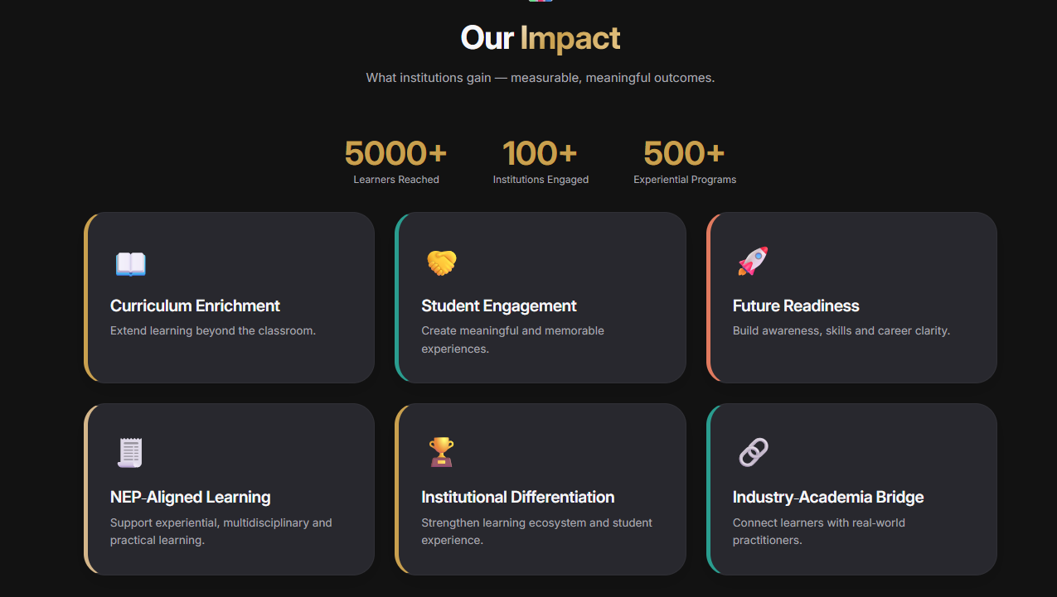

Section 3 .
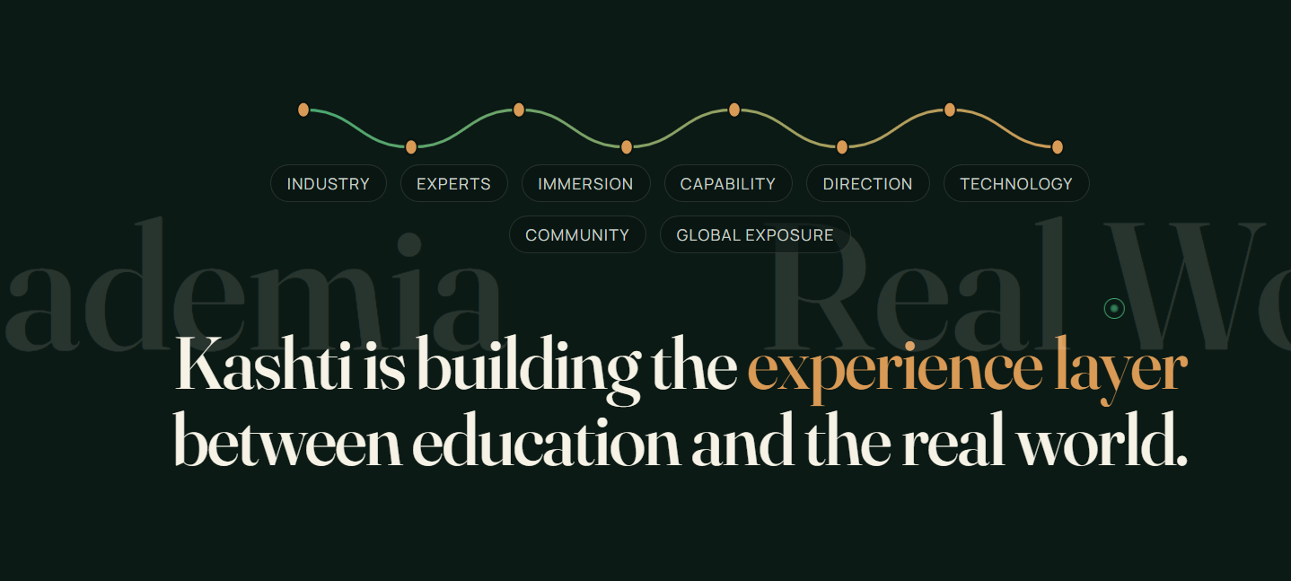

Section 4
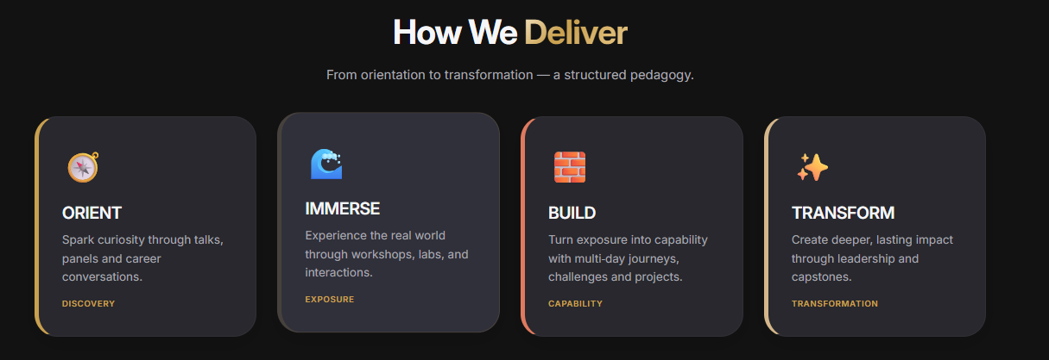

Section 5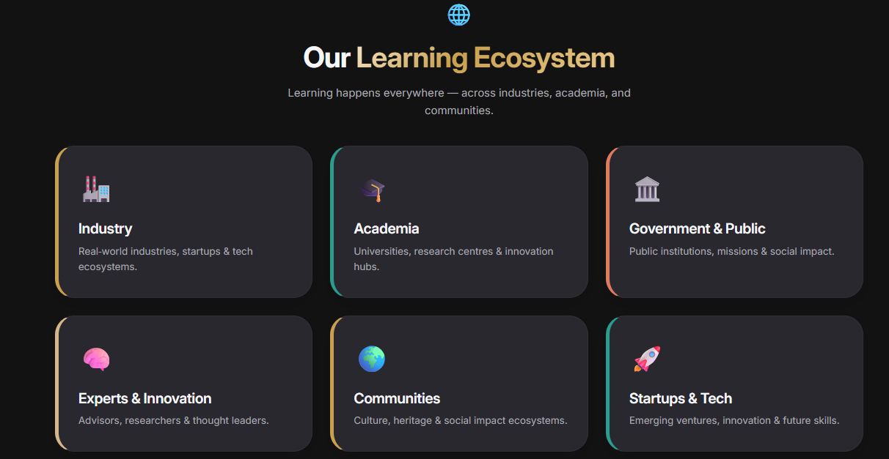

Section 6
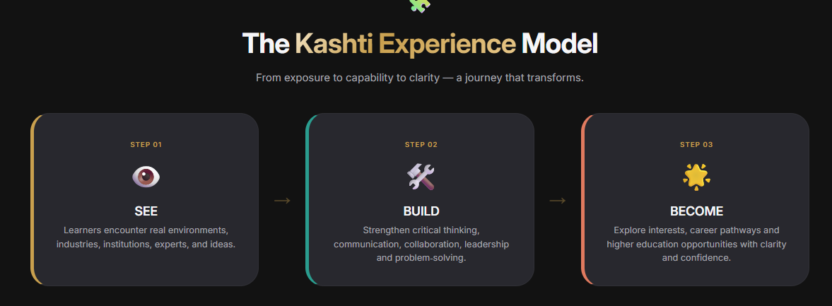
Page PROGRAMS & EXPERIENCES/THE KASHTI EXPERIENCE PORTFOLIO
Different institutions. Different needs. One experiential learning system.

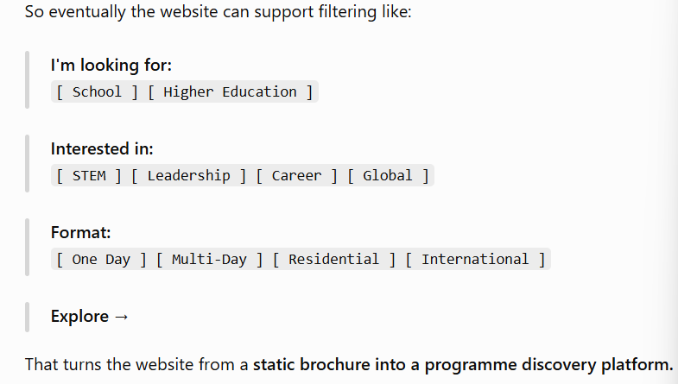
BUILD THIS EXPERIENCE FOR YOUR INSTITUTION
REQUEST PROGRAMME DETAILS →
or
DESIGN THIS FOR OUR STUDENTS →

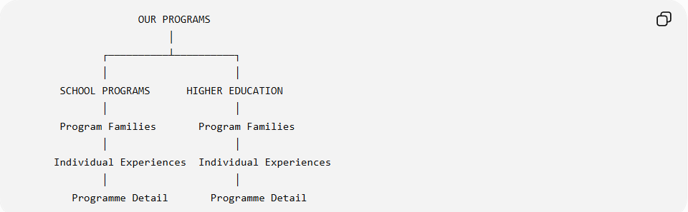
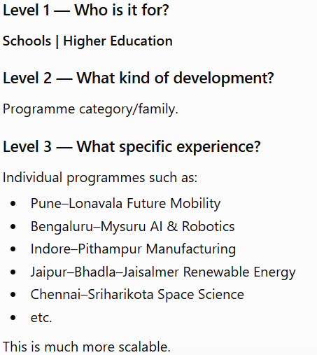
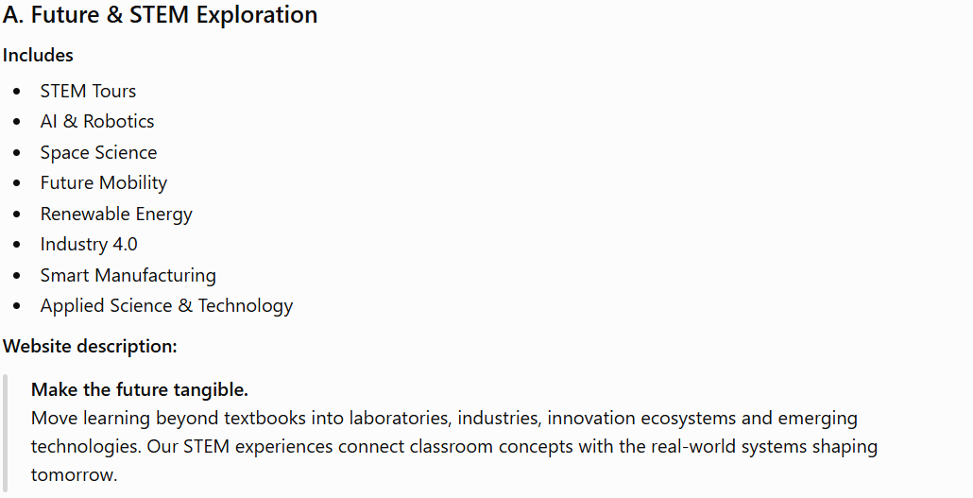
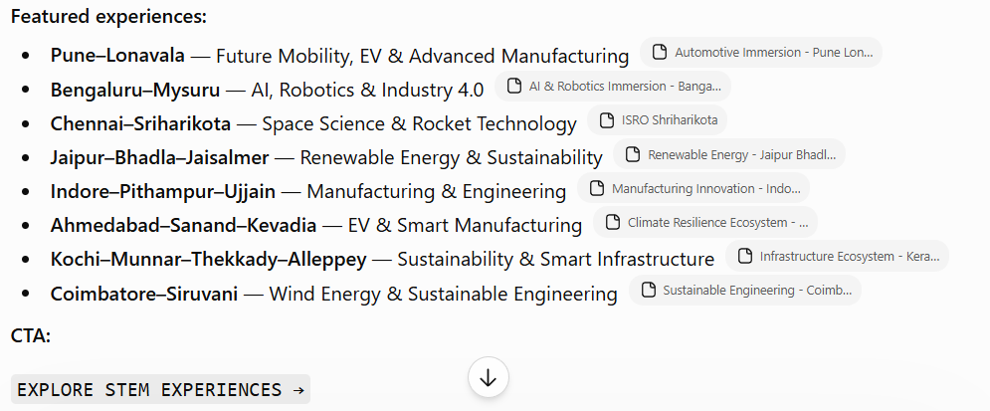
3. Leadership, Discipline & Character
This combines the source categories:
- Boot Camps & Discipline Programmes
- Skill Development Programmes
- Leadership-oriented experiential learning
- Character development
Website description:
Build the person behind the performance.
Structured residential and outdoor experiences designed to develop discipline, resilience, leadership, teamwork, decision-making and personal responsibility.
CTA:
EXPLORE LEADERSHIP PROGRAMMES →
This category should eventually house your SACA-style programmes and other structured camps rather than mixing them with tourism products.
4. Adventure & Experiential Learning
Includes
- Experiential & Adventure Learning
- Applied & Outdoor Learning
- Day Excursions
- Nature-based experiences
Website description:
Learning through doing.
Adventure, outdoor challenges, exploration and collaborative experiences that turn unfamiliar environments into opportunities for confidence, problem-solving, teamwork and discovery.
CTA:
EXPLORE EXPERIENCES →

5. Career & Industry Exposure
This is particularly important because it moves Kashti away from being perceived as a tour operator.
Includes
- Industrial Visits
- Career Exposure
- Industry Connect
- Skill Development
- Expert interactions
- Workplace exposure
The existing programme PDFs already demonstrate this architecture through manufacturing facilities, technology ecosystems, expert interactions and career-awareness sessions.
Website description:
Let students see where learning leads.
Connect students with industries, professionals, workplaces and emerging careers through structured exposure designed around curiosity, application and career awareness.
CTA:
EXPLORE INDUSTRY & CAREER PROGRAMMES →

6. University & Future Pathways
Includes
- University Exposure Programmes
- Higher Education Awareness
- Career Discovery
- Academic ecosystem exposure
Website description:
Turn aspiration into direction.
Give students an opportunity to experience universities, academic environments, emerging disciplines and future pathways before they make important educational decisions.
CTA:
EXPLORE UNIVERSITY PROGRAMMES →

7. Culture, Wellness & Social Development
This combines the more human-development-oriented categories:
- Spiritual & Wellness Retreats
- Heritage & Culture
- Social responsibility
- Community experiences
- Border & Patriotism
- Indian Knowledge Systems
Website description:
Develop perspective beyond the classroom.
Cultural, heritage, wellness, community and national experiences that help students understand identity, responsibility, resilience and their relationship with the wider world.
CTA:
EXPLORE CULTURE & WELLNESS →

8. Global & International Immersion
This deserves to stand independently rather than being buried under travel.
Includes
- Global Immersion Programmes
- International exposure
- Cross-cultural learning
- International academic/industry exposure
Website description:
Expand the student's world.
International experiences designed around cross-cultural understanding, global exposure, academic discovery, industry ecosystems and global citizenship.
CTA:
EXPLORE GLOBAL PROGRAMMES →
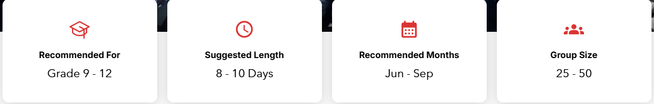
HIGHER EDUCATION PROGRAMS
Here I would be much more faithful to the second image because its categorisation is already strong.
The seven categories are:
- Academic & Industry Exposure
- Entrepreneurship & Innovation
- Career Development
- Experiential Learning
- Global Learning
- Alumni Programs
- Faculty Programs
This should become a very clean 7-card grid.

01 — Academic & Industry Exposure
Includes
- Industrial Visits
- Corporate Exposure
- Manufacturing Cluster Visits
- Research & Innovation Centre Visits
- Business Smart Tours
- International Trade Fair & Expo Tours
- Canton Fair Business Tours
- Startup Ecosystem Visits
- MSME Exposure Programmes
Website copy:
Take academic learning into the real economy.
Connect students with companies, manufacturing ecosystems, research centres, startups and business environments to understand how industries actually operate.
CTA:
EXPLORE INDUSTRY EXPOSURE →

02 — Entrepreneurship & Innovation
Includes
- Entrepreneurship Exposure Tours
- Founder Learning Expeditions
- Startup Immersion
- Innovation Labs
- Incubator & Accelerator Visits
- Business Leadership Journeys
- Social Entrepreneurship Programmes
Website copy:
Go where ideas become ventures.
Immersive experiences connecting students with founders, startups, incubators, innovation ecosystems and entrepreneurial leaders.
CTA:
EXPLORE ENTREPRENEURSHIP PROGRAMMES →

03 — Career Development
Includes
- Career Exposure
- Industry Connect
- Leadership Development
- Skill Development
- Campus-to-Corporate
- Placement Readiness Retreats
Website copy:
Bridge the gap between campus and career.
Experiences designed to build professional awareness, workplace understanding, leadership capability and readiness for the transition from education to employment.
CTA:
EXPLORE CAREER PROGRAMMES →

04 — Experiential Learning
Includes
- Adventure Leadership Camps
- Trekking Expeditions
- Outdoor Leadership
- Community Service
- Cultural & Heritage
- Border Tourism
- Educational Excursions
Website copy:
Learn through experience, challenge and reflection.
Outdoor, cultural, leadership and community experiences designed to develop capabilities that traditional classroom environments cannot replicate.
CTA:
EXPLORE EXPERIENTIAL PROGRAMMES →

05 — Global Learning
Includes
- University Exchange
- Global Immersion
- International Business Delegations
- Cross-Cultural Learning
Website copy:
Put students into a global context.
International academic, business and cultural experiences that broaden perspective, build global competence and connect students with new ecosystems.
CTA:
EXPLORE GLOBAL LEARNING →

06 — Alumni Programs
Includes
- Alumni Reunion Retreats
- Networking Retreats
- Leadership Retreats
Website copy:
Turn alumni networks into active communities.
Curated retreats and experiences designed to reconnect alumni, strengthen professional networks and create meaningful institutional engagement.
CTA:
EXPLORE ALUMNI PROGRAMMES →

07 — Faculty Programs
Includes
- Faculty Development Programmes
- Academic & Research Exposure
- International Faculty Immersion
- Wellness & Spiritual Retreats
- Team Building
Website copy:
Develop the people who develop students.
Faculty-focused experiences combining professional development, academic exposure, research, international learning, wellbeing and team building.
CTA:
EXPLORE FACULTY PROGRAMMES →

Section 8
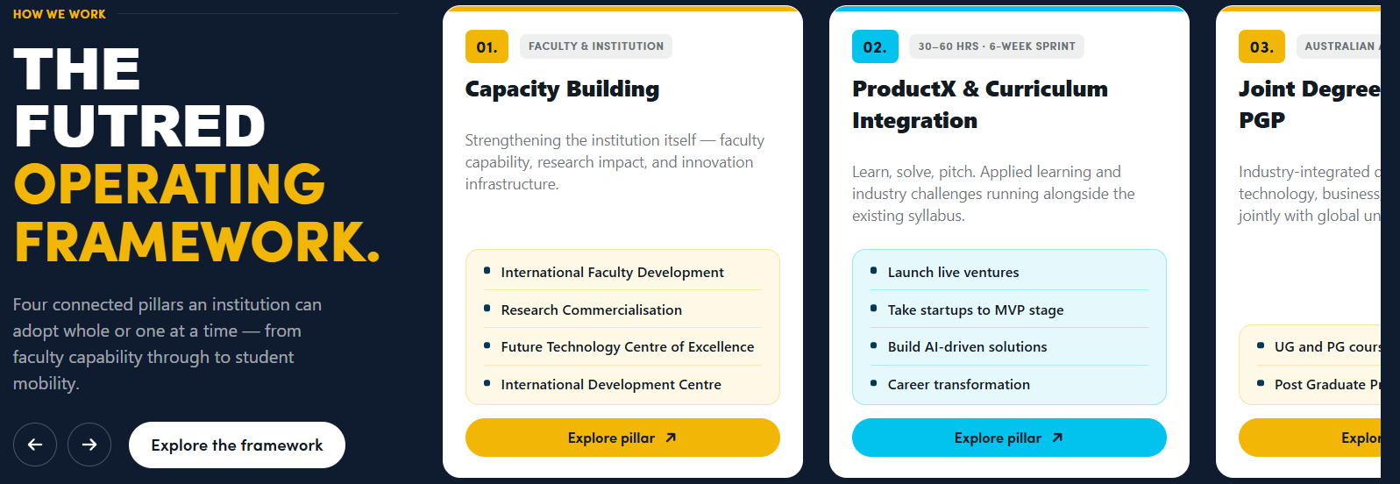
Footer.

